INDEX
1．Safety Precautions and Warnings 2
2. Using the Scan Tool 4
2.1 Tool Description 4
2.2 Specifications 5
2.3 Accessories Include 5
2.4 Product Troubleshooting 6
3. C50X series Model description 7
4. Software Function 7
4.1 System setting 9
A.SYSTEM INFORMATION 9
B.BEEPER 10
C.LANGUAGE SETUP 10
5. Diagnostics 12
5.1 Strat Daignostic 12
5.2 Read Trouble Code 15
5.3 Erasing Codes 16
5.4 Read DataStream 17
5.5 Vehicle Information 19
5.6 Quit Diagnostic 20
6. Software update 20

1．Safety Precautions and Warnings
To prevent personal injury or damage to vehicles and/or the scan tool. Read this instruction manual first and observe the following safety precautions at a minimum whenever working on a vehicle.

·Always perform automotive testing in a safe environment.
·Wear safety eye protection that meets ANSI standards.
·Keep clothing, hair, hands, tools, test equipment, etc. Away from all moving or hot engine parts.
·Operate the vehicle in a well ventilated work area: Exhaust gases are poisonous.
·Put blocks in front of the drive wheels and never leave the vehicle unattended while running tests.
·Use extreme caution when working around the ignition coil, distributor cap, ignition wires and spark plugs. Theses components create hazardous voltages when the engine is running.
·NEUTRAL (for manual transmission) and make sure the sparking brake is engaged.
·Keep a fire extinguisher suitable for gasoline/chemical/electrical fires nearby.
·Don’t connect or disconnect any test equipment while the ignition is on or the engine is running.
·Keep the scan tool dry, clean, free from oil/water or grease. Use a mild detergent on a clean cloth to clean the outside of the scan tool, when necessary.

2. Using the Scan Tool

2.1 Tool Description
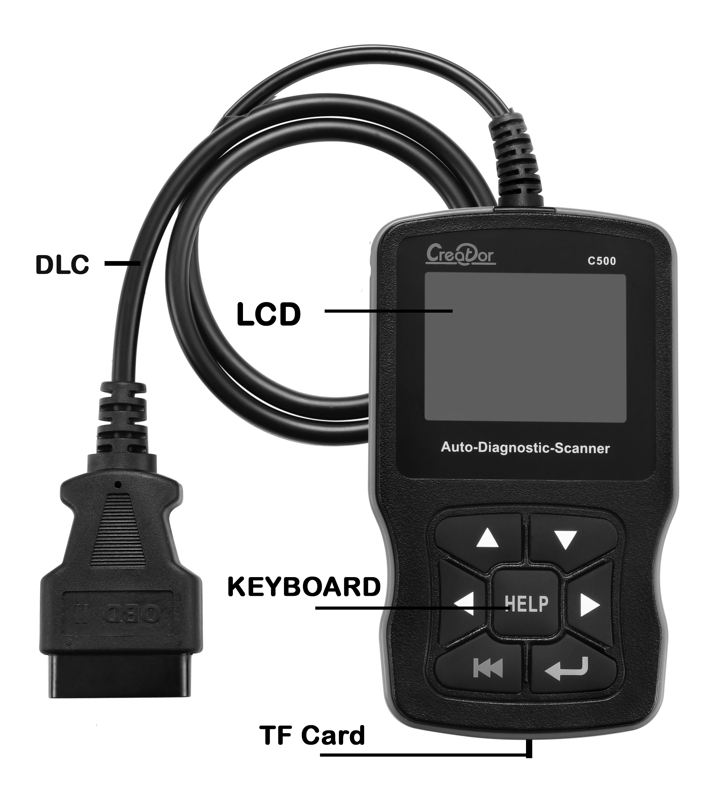

① DLC -- Data Link Connector (DLC), Use to connect the scan tool to the vehicle;
② LCD DISPLAY -- Indicates test results. Color, 320 x 240 pixel display with contrast adjustment
③ KEY BROAD – include [][][][][] [] [HELP]
④ TF card -- use to store the application software;

2.2 Specifications
A) Display: Color, 320 x 240 pixel display with contrast adjustment
B) Operation Temperature: - 20 ℃ -- 75 ℃
C) Storage Temperature: -40 ℃ -- 120 ℃
D) Power: 8V -- 24V
E) Dimensions:
Length | Width | Height
150mm | 85mm | 28mm
F) Weight
Net Weight: 350 g
Gross Weight: 500 g

2.3 Accessories Include
A) User’s Manual – Instructions on tool operations.
B) TF card – use to store the application software, Capacity: 1GB

2.4 Product Troubleshooting
Vehicle Linking Error
A communication error occurs if the scan tool fails to communicate with the vehicle’s ECU (Engine Control Unit). You need to do the following to check up:
A) Verify that the ignition is ON;
B) Check if the scan tool’s OBD II connector is securely connected to the vehicle’s DLC;
C) Verify that the vehicle is OBD2 compliant;
D) Turn the ignition off and wait for about 10 seconds. Turn the
E) Ignition back to on and continue the testing.
F) Verify the control module is not defective

Scan tool doesn’t power up
If the scan tool won’t power up or operates incorrectly in any other way, you need to do the following to check up:
A) Check if the scan tool’s OBD II connector is securely connected to the vehicle’s DLC;
B) Check if the DLC pins are bent or broken. Clean the DLC pins if necessary.
C) Check vehicle battery to make sure it is still good with at least 8.0 volts.

3. C50X series Model description

Model | Support vehicle
C501 | BMW & OBDII/EOBD
C502 | BENZ & OBDII/EOBD
C507 | HONDA/ACURA & OBDII/EOBD
C508 | FIAT & OBDII/EOBD
… | …

4. Software Function
CATION: Don’t connect or disconnect any test equipment with ignition on or engine running.
- Turn the ignition off.
- Locate the vehicle’s 16-pin Data Link Connector (DLC)
- Plug into the scan tool cable connector to the vehicle's DLC ，the scan tool will be light. As shown
- Turn the ignition on. Engine can be off or running


- Wait for a moment to enter select vehicle menu

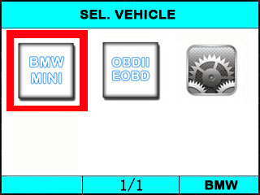
USE the key [][][][] to select in the [SEL. VEHILCE] , and press [] to selection the vehicle which you want to diagnostic

4.1 System setting
Select [] in the [SEL. VEHICLE] and press []. The screen will display the interface as shown below:
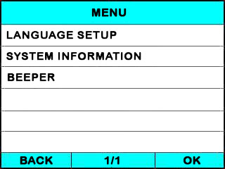
The scanner allows you to make the following adjustments settings;

A.SYSTEM INFORMATION
Choose [SYSTEM INFORMATION] and press [].
The screen will display the interface as shown below:
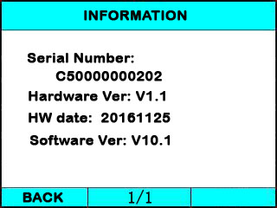
Press [] or [] to return the [SYSTEM SETTING]

B.BEEPER
Choose [BEEPER] and press [], the screen will display the interface as shown below:
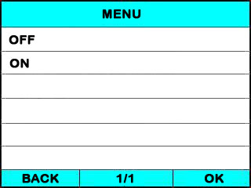
Press [][] to select, and press [] to confirm.

C.LANGUAGE SETUP
Choose [LANGUAGE SETUP] and press [], the screen will display the interface as shown below:
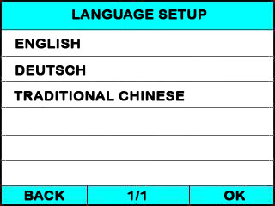
Press [][] to select, and press [] to select the language what you want to use.

5. Diagnostics

5.1 Strat Daignostic
You can Select defference vehicle to Diagnostic, for example, select [BMW&MINI] and press [].
The screen will display loading the App. ,the interface as shown below:
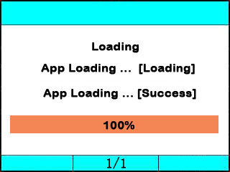
When Loading sussce, it will enter the Menu for Diagnostic,you can use the Keyboard [][] to select, [] and [] to Page, and press [] to confirm.
For example , you select [],and press [], the OBDII application software will be loaded , after Load successfully, the screen will display he interface as shown below:
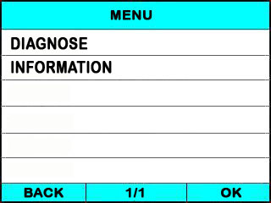
You can select the [INFORMATION] , and press [], the screen will display the App software information as shown below:
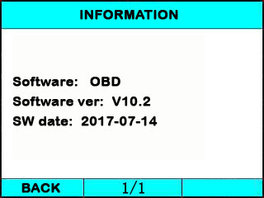
press [] or [] to return the first menu.

You can select the [DIAGNOSE] , and press [], the APP software will start test the vehicle.as the screen display below:
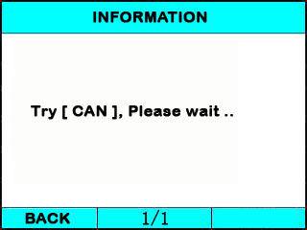
The tools will try different mode of communication, like [CAN 11] , [CAN 29] , [J1850 VPW] , [J1850 PWM] , [ISO 9141], [KWP 2000] etc.

◆if the scan tool fails to communication with the vehicle’s ECU, a “ERROR” message shows up on the display
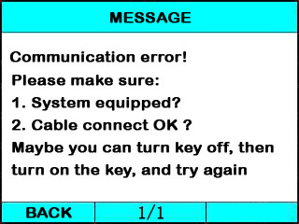

if the scan tool communicate with the vehicle, it will enter the [function menu], the screen will display the interface as shown below:
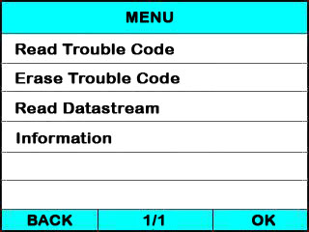
Press [][] to select, [] and [] to Page, and press [] to confirm.

5.2 Read Trouble Code
◆Reading Codes can be done with the key on engine off (KOEO) or with the key on engine running (KOER).
◆Trouble codes cause the control module to illuminate the malfunction indicator lamp (MIL) when emission-related fault occurs.

select [Read Trouble Code] and press [] in [Diagnostic Menu]. If there are some codes, the screen will display the codes as show below:
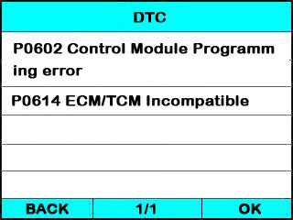
Press [] or [] to return the [Diagnostic menu]

View DTCs and their definitions on screen.
􀁺 If there are no Diagnostic Trouble Codes present, the display indicates “No Trouble Code” Wait a few seconds or press any OK to return to Diagnostic Menu.
􀁺 The control module number, sequence of the DTCs, total number of codes detected and type of codes (Generic or Manufacturer specific) will be observed on the upper right hand corner of the display.

5.3 Erasing Codes
CAUTION: Erasing the Diagnostic Trouble Codes may allow the scan tool to delete not only the codes from the vehicle’s on-board computer,
- This function is performed with key on engine off (KOEO). Do not start the engine.
Select [Erase Trouble Code] and press[] in [Diagnostic Menu]. the screen will display the interface as shown below:
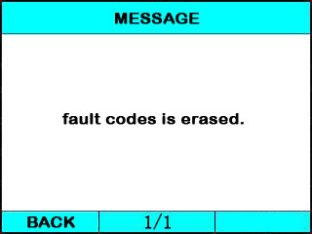
Press [] or [] to return the [Diagnostic menu]

Notes:
* Before performing this function. Make sure to retrieve and record the trouble codes.
* After clearing, you should retrieve trouble codes once more or turn ignition on and retrieve codes again. If there are still some trouble codes for hard troubles, please find the reason caused the trouble code first, and then solve the problem. Now, the trouble codes can be erased.

5.4 Read DataStream
The Read DataStream function allows viewing of live or real time data of vehicle’s computer module(s). This function is not supported for some system.
Press[][] to select [Read DataStream] in [Diagnostic Menu] and press [] to confirm. The screen will display the interface as shown below.
Data model
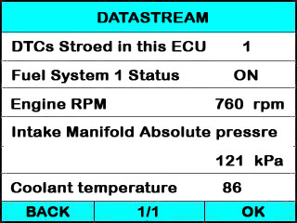
If appear [GRAPH], Press [] to enter Graph mode.
Press [] to return [Diagnostic Menu]
the screen will display the interface as below:
Graph model
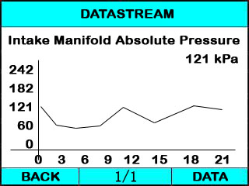
Press [] to return data model. Press [] to return [DIAGNOSTIC MENU].

5.5 Vehicle Information
Vehicle Information function is to display the ECU information, including Software version, hardware version, diagnostic index, pro. Date, part number ECT. This function is not supported by some system.
Select [Vehicle information] in the [Diagnostic Menu], and Press []. The screen will display as shown below:
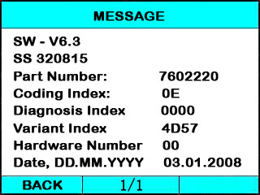
Press [] to return data model. Press [] to return [DIAGNOSTIC MENU].

5.6 Quit Diagnostic
In the [DIAGNOSTIC MENU] press[] key, the screen will display as shown below:
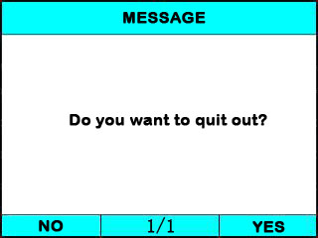
Press [], it will quit out the Diagnostic App and return the select vehicle menu.
Press [], it will return Diagnostic main menu

6. Software update

Please visit the website: www.szcreator.com and Read the new upgrade description about C50X.

